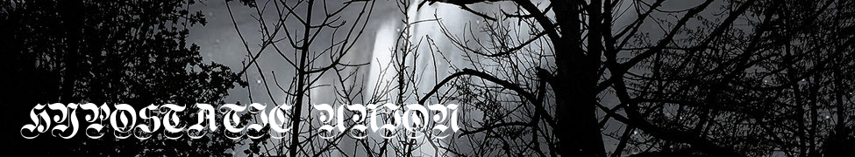

NEW DRONE / DARK AMBIENT PROJECT FROM
EXTREME NOISE TERROR / DOOMED BIRD OF PROVIDENCE BASSIST
Featuring contributions from John Hannon (Liberez), Lara Rix-Martin (Meemo Comma) and James Sarek (Zophocles)

Enclosed & Silent Order:
“Opuštěný”
LP and Bandcamp download
https://enclosedandsilentorder.bandcamp.com/
Release date 02.03.2020
Label: Hypostatic Union

New dark ambient / drone project ENCLOSED & SILENT ORDER sees its debut release on 2nd March 2020, via Bandcamp download and a limited run of 20 clear lathe-cut LPs.

Headed by sometime Extreme Noise Terror bassist Stafford Glover (12 years with the band and continued live work and occasional writing contributions today), the project is a shaking off of limiting creative structures – short pieces were recorded on down time at No Recording Studio in Essex, with resulting material being distributed to friends Lara Rix Martin and James Sarek with little in mind other than a vague curiosity as to what would happen. Excited by the results and armed with the production skills and instrumental contributions of John Hannon, the project took shape over Autumn and Winter 2019, this album being the result.

Thematically, “Opuštěný” draws on an apprehension of the silent unseen spirit of the Essex wilderness, its liminal spaces and the presence of the numinous therein, coupled with feelings and unspoken knowings experienced on travels in Eastern Europe.
http://enclosedandsilentorder.bandcamp.com/

Hypostatic Union
…is a new label vehicle which aims to explore divine essence or inquiry, using dark and “new” or experimental musical forms.

https://hypostaticunion.bandcamp.com/

Live
14.05.2020
Control Voltage @ The Railway Inn, Southend
with bÖsch + Halina Rice + Ramjac Corporation

Ends

